1. T=300K

|  |  |
| --- | --- |
| l | P |
| 6 | 982 |
| 8 | 739 |
| 10 | 592 |
| 12 | 492 |
| 15 | 394 |

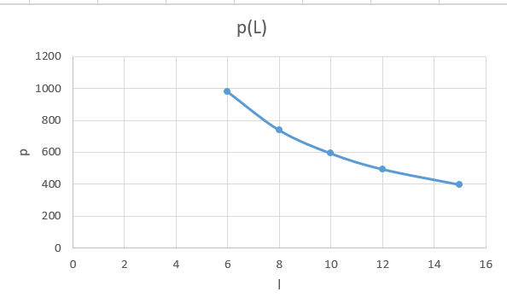

1. V=const

|  |  |
| --- | --- |
| T | P |
| 300 | 982 |
| 347 | 1137 |
| 364 | 1193 |
| 438 | 1435 |
| 506 | 1656 |

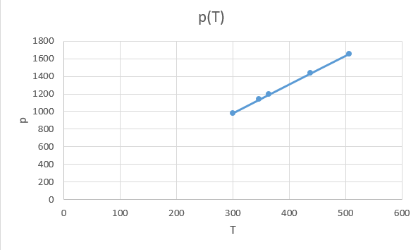

1. P=const

|  |  |
| --- | --- |
| T | l |
| 506 | 6 |
| 609 | 7,3 |
| 688 | 8,2 |
| 847 | 10,1 |
| 995 | 11,8 |

